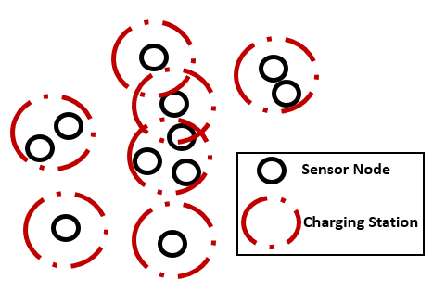

Figure 2. Typical example of WRSN in indoor environment